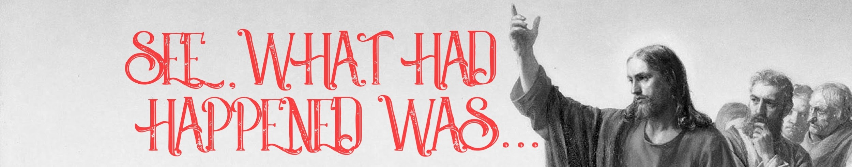
Part 1: The Temptations
As you read Matthew 4:1-11 --underline nouns; double underline verbs; circle descriptive words; make a list of the key words.

What are the main points of this passage?
________________________________________________________________________________
________________________________________________________________________________
________________________________________________________________________________
________________________________________________________________________________
________________________________________________________________________________
________________________________________________________________________________
________________________________________________________________________________
________________________________________________________________________________
________________________________________________________________________________
________________________________________________________________________________
________________________________________________________________________________
________________________________________________________________________________
________________________________________________________________________________
________________________________________________________________________________
________________________________________________________________________________
________________________________________________________________________________
________________________________________________________________________________
________________________________________________________________________________
________________________________________________________________________________
Additional Resources: | www.cornerstonecc.church/whathadhappenedwas  Try our parent guides: www.cornerstonekids.church
Study Guide

What stood out to you from the Sunday message?
Matthew 4:1 (Matthew 3:16-17)
- Why do you think we give in to temptation?
- What was at stake when Jesus was tempted?
- How could your response to temptation impact your future?

Matthew 4:2-4
- What was behind the devil's request? Why would it have been a sin for
Jesus to turn the rocks into bread?
- Why is it difficult to wait on God to provide?
- Give examples of how we try to meet legitimate needs in a way that’s not pleasing to God.

Matthew 4:5-7
- What was behind the devil's request? Why would it have been a sin for
Jesus to throw himself down from the top of the temple?
- What are some ways we misuse the bible to justify our actions?

Matthew 4:8-11
- Why did Satan tempt Jesus to take a shortcut to get something that would already be his later?
- Have you been tempted to abandon your values to get what you want?
_________________________________________________________________________________________________________
Challenge: Identify some areas where you are most likely to give into temptation. This week find some verses you can use to help you fight off these temptations when they come.

Dig: Romans 6:14; Deut 8:1-3; Mark 1:9-13; Luke 4:1-13; James 1:13-15; Genesis 39:6-20; Mark 14:38; 1 Corinthians 10:13; James 1:12

THANK YOU FOR YOUR GENEROSITY!!!
Your giving provides ministry that changes lives.
2019 Giving Goal: $507,000 | Current Giving: $84,602
Give Online: www.cornerstonecc.church/give
Mobile Giving: Text “GIVECCC” to 77977 (Msg & Data rates may apply)

