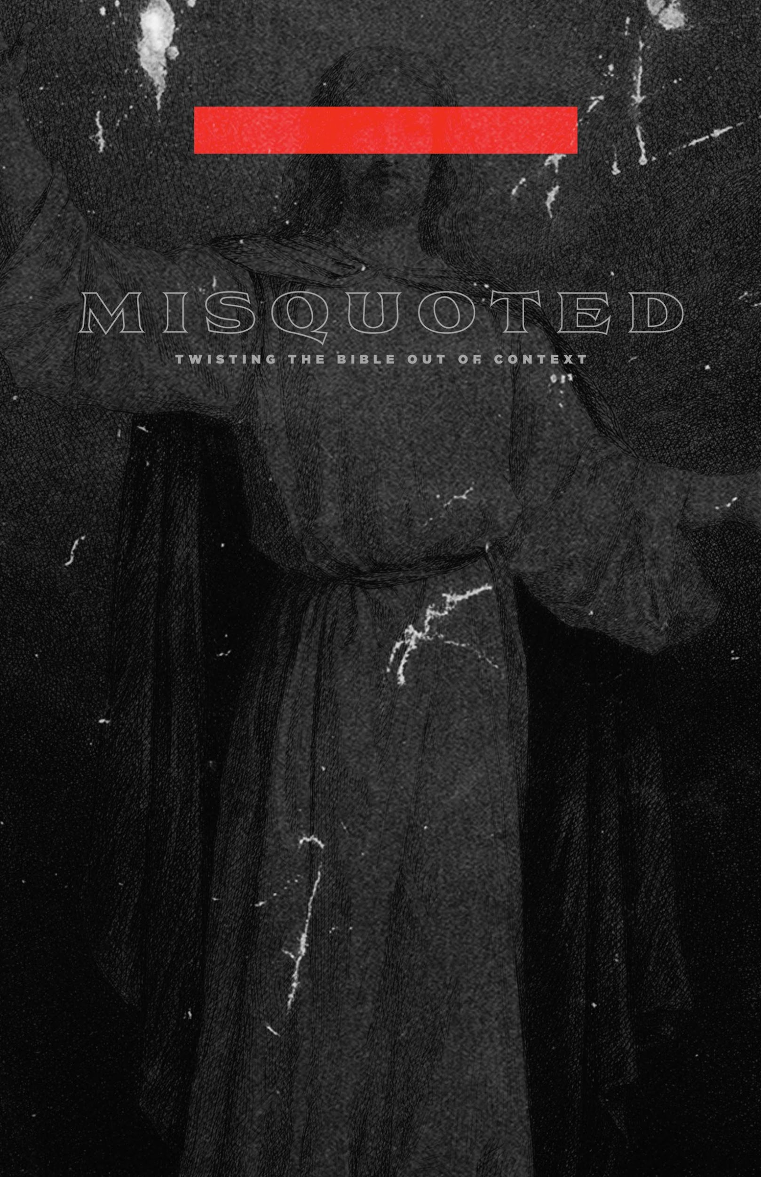

SMALL GROUP QUESTIONS
Week 1
Text: Romans 8:28–30
Topic(s): Christlikeness, Sanctification
Big Idea of the Message: Our culture today tells us to be true to ourselves. Unfortunately, it doesn’t work like that in God’s kingdom; the gospel calls us to be conformed not to ourselves, but to the image of Jesus Christ.
Application Point: Rather than trying to earn our identity and be accepted by the world around us (which is a crushing burden), we should receive the identity that has been given to us in and through the gospel: we are called sons and daughters of God.

Discussion Questions:

  - What is one thing that stood out to you from this week’s message?

  - Have you ever heard anyone say, “Be true to yourself”? What was the situation it was used in?

  - How have you encountered this idea of being true to yourself in our culture? Movies? Music?

  - Why is it impossible to avoid letting others define you?

  - Why is being true to yourself such a heavy burden?

  - How can I pray for you?

Week 2
Text: James 1:2–4
Topic(s): Perseverance, Suffering, Joy
Big Idea of the Message: Our highly spiritual culture tends to understand God and religion as “therapeutic,” meaning, “God/religion will help me feel good.” On the contrary, the gospel presents us with a suffering Savior who calls us to also take up our crosses and follow him.
Application Point: God is at work through your pain and suffering to conform you into his image, which is the image of Jesus.

Discussion Questions:

  - What is one thing that stood out to you from this week’s message?

  - What is “Moralistic Therapeutic Deism”? Is this the common religious belief of your friends/colleagues? Do you see any similarities between it and your own beliefs?

  - Why is your concept of God important for how you live?

  - What’s the difference between abstract and concrete? How is Jesus important to our understanding of what God is like?

  - Discuss Elie Wiesel’s story. What does it say to you?

  - How can I pray for you?

Week 3
Text: Luke 6:20–26
Topic: Social Justice, Gospel
Big Idea of the Message: Many wrongly assume that social justice is a distraction from the “real work” of the gospel. But Jesus was continually caring for those on the margins of society.
Application Point: The gospel has strong implications for how we treat socially marginalized people. Justice is a gospel issue, and Christians are commissioned to be agents of God’s reconciliation in the world.

Discussion Questions:

  - What is one thing that stood out to you from this week’s message?

  - Have you ever heard anyone say that social justice isn’t a gospel issue? Would those same people say that morality isn’t a gospel issue? Why or why not?

  - Why do you think God would give special attention to the “quartet of the vulnerable”? Should we emulate that?

  - How is the gospel not just good news spiritually to all, but actually good news to the materially poor as well?

  - Have you ever experienced Jesus’s presence while ministering to the “quartet of the vulnerable”?

  - How can I pray for you?
Week 4
Text: James 3:1–12
Topic(s): Power of Words, Incarnation
Big Idea of the Message: Many believe we can alter our life situations through the power of positive thinking or speaking. While words are very powerful, they are not as powerful as God’s creative word. Moreover, our words are corrupt and in need of healing.
Application Point: The gospel offers us hope that our words can become vehicles for reconciliation rather than destruction. We must see the truth and the love of God’s Word become flesh for us.

Discussion Questions:

  - What is one thing that stood out to you from this week’s message?

  - Have you ever heard people talk about the power of positive thinking/speaking?

  - Words are powerful. Would anyone be willing to share an example from you own life of ways that words have had a powerful positive or negative impact on you?

  - How is truth not really truth without love? How is love not really love without truth?

  - How do truth and love meet on the cross?

  - How can I pray for you?

